In 2018, Cambridge Analytica was in the news in the United Kingdom and the USA (Confessore, 2018) for obtaining and sharing data obtained from millions of Facebook users. They obtained the data through innocuous surveys on Facebook (you may have seen this type of survey and probably participated at times). This is probably the highest profile of surveys used for alternative means and, probably, monetary gains. However, this happens often through various media.

Consider how exactly this happened and why it was used. Find one or two further examples of inappropriate use of surveys and highlight the impact of all these examples from the various ethical, social, legal and professional standpoints that apply.

Record your findings in your e-Portfolio. You can also submit your findings to your tutor for formative feedback.

"Would you be comfortable sharing with us the name of the hotel you stayed in last night?" the question from Senator Dick Durbin made the Facebook C.E.O. Mark Zuckerberg speechless during the investigation related to Cambridge Analytica. But unfortunately, we have witnessed many cases like Cambridge Analytica. According to a survey, more Americans are concerned about sharing personal data online (BCG Big Data and Trust Consumer Survey, 2015). See figure 1 below.

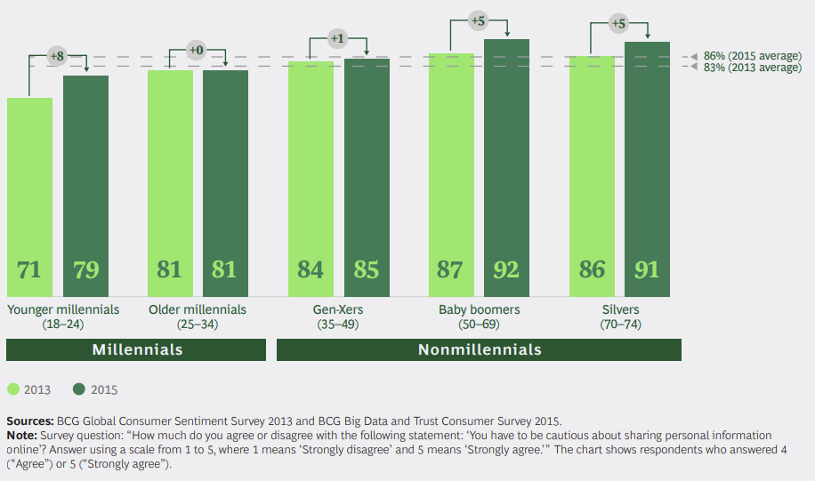

Figure 1 (BCG Big Data and Trust Consumer Survey, 2015)

In addition, consumers are primed to suspect data misuse, and the distrust is high among those in the US and Europe (BCG Big Data and Trust Consumer Survey, 2015). See figure 2 below.

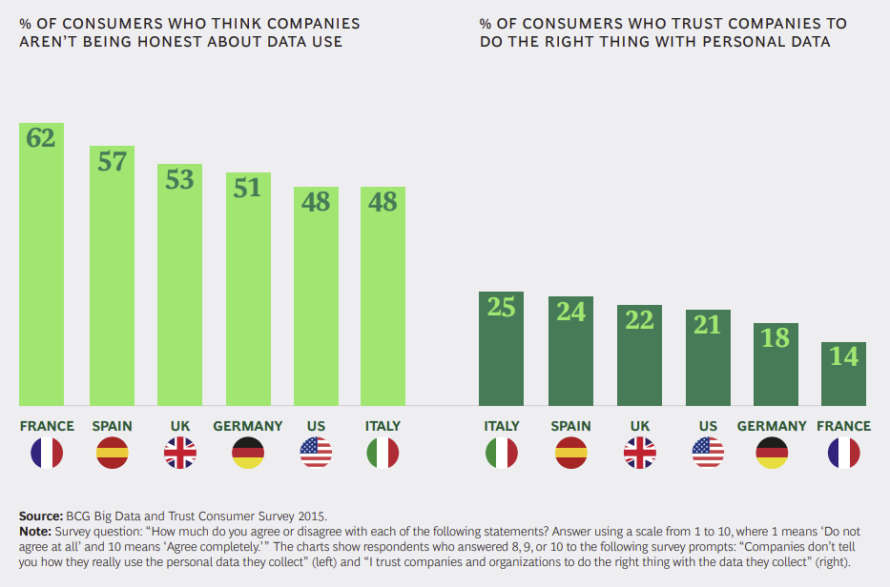

Recently in Canada, the GiveSendGo hack revealed the names of thousands who donated to 'Freedom Convoy'. This resulted in many issues, including government employees being involved in politically motivated protests (NationalPost, 2022).